**Developing REACT Applications The Prof’s Lab Notebook**

Working with the Command Line

Tools you need to install:

|  |  |
| --- | --- |
| Node.js |  |
| Visual Studio Code |  |
| PowerShell |  |
| hyper.is | Hyper Terminal |

Important Websites:

|  |  |
| --- | --- |
| NPMJS.com | The source for NPM Packages |
|  |  |
|  |  |

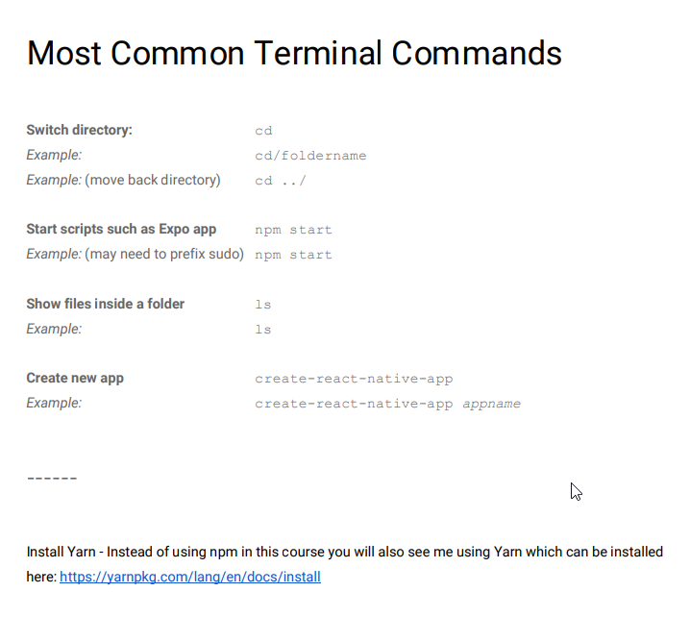

**Build your first app with React Native and Expo**

Study the details of the NPM Package create-react-native-app on NPMJS.com and then perform the following set of Lab Steps:

Pre-requisites for this Activity:

** You have Node.js installed

Aside:

NPX, NPM, Yarn, Chocolatey : how do they work together?

https://medium.com/@maybekatz/introducing-npx-an-npm-package-runner-55f7d4bd282b

npx create-react-native-app

Open your new project in EXPO, sync your Phone, and in Expo: Code your App.js as follows:

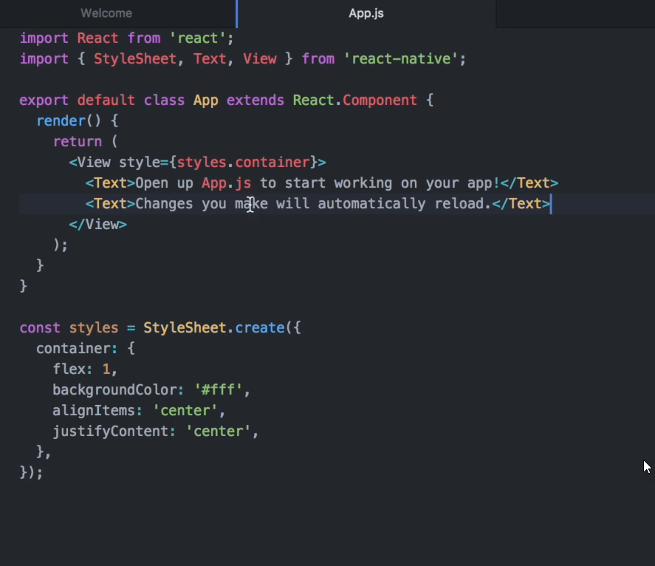

Bringing an Image into your App

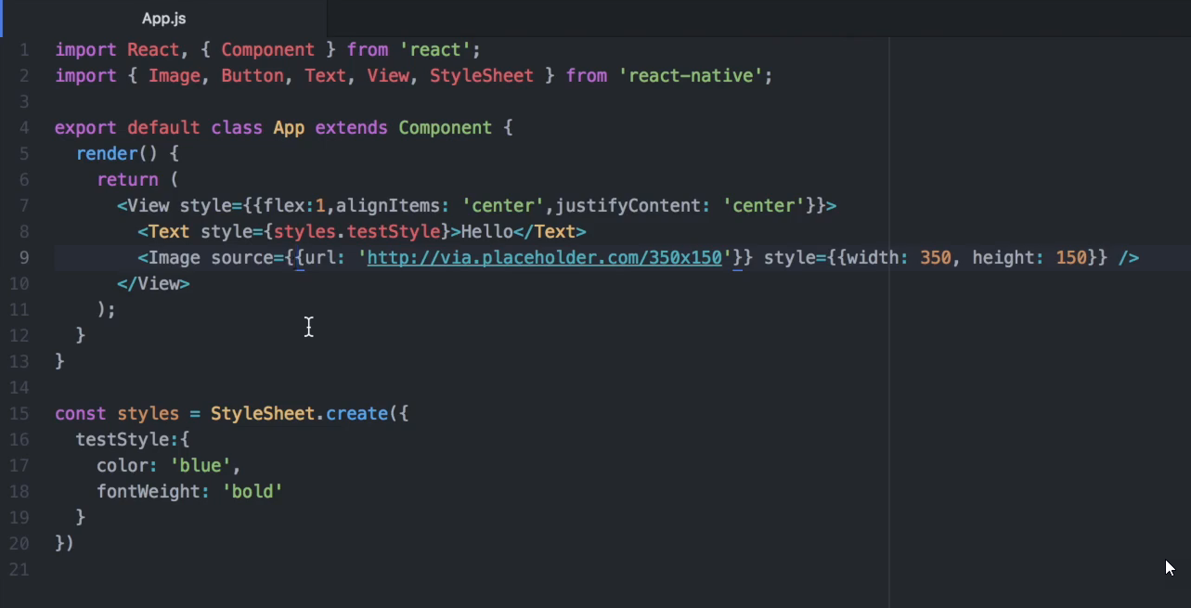

Using PROPS:

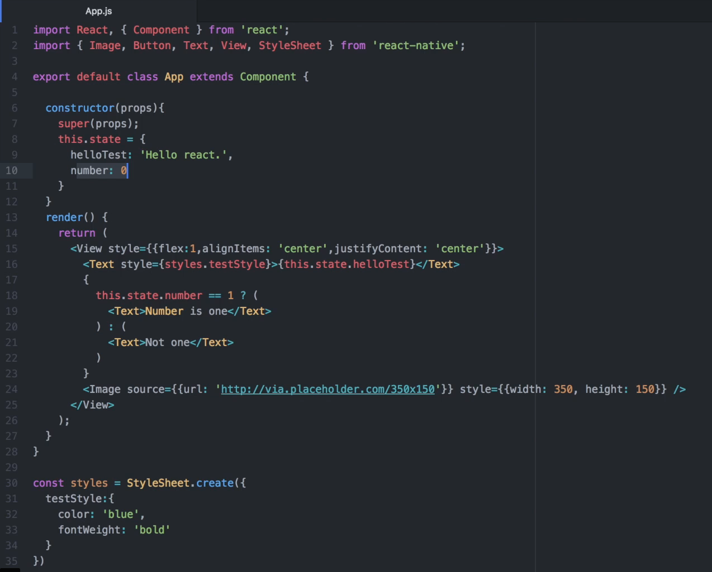

How to write a Simple REACT App with Component Navigation: